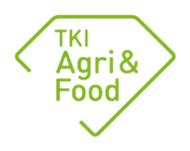
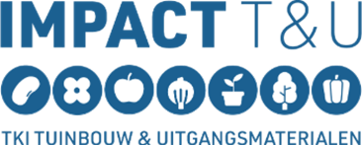
May 2026 version

_________________________________________________________________________________
PPP proposal title:
Please submit your proposal by no later than September 1st 2026 via the submission link on this page
_________________________________________________________________
General information
Applicant/coordinator contact details (i.e. not the research institute)
Name: …
Organisation: …
E-mail address: …

Research institute contact details
Name: …
Organisation: …
E-mail address: …

The PPP proposal will contribute to the following mission:
1. Resilient nature
2. Sustainable agriculture and horticulture
3. Vital rural areas in a climate-resilient Netherlands
4. Sustainable and valued food that is healthy, accessible and safe
5. Sustainable and safe use of the North Sea and other large water bodies
Or to the following key technology: ST1. Smart technologies for the blue-green domain
ST2. Biotechnology and breeding
ST3. Fermentation and bioconversion

Please note: place an X in one box only

If a mission has been selected, to which Innovation Programme and mission does the proposal relate to?
(Select only one Innovation Programme, please check the KIA LWV 2024-2027 for a complete overview)

If a key technology has been selected, to which Innovation Programme and mission does the proposal relate to?
(Select only one Innovation Programme, please check the KIA LWV 2024-2027 for a complete overview)

TRL at the start of the project
(Please specify a single TRL level. See the RVO definition. Please note: stricter co-financing requirements are applicable to TRL levels higher than 4).

Brief summary of the PPP proposal
(max. half a page A4; this content will be published on the KIA website)

_________________________________________________________________________________
PPP proposal (max. 10 pages)
Please include any background information in the annexes (these do not count towards the ten pages). The following annexes are mandatory:
Annex 1: Detailed Impact Plan Approach
Annex 2: State of the art and deliverables
Annex 3: Comprehensive multi-year working plan
Annex 4: Detailed consortium partner information

The TKIs recommend that applicants use the Impact Plan Approach as a tool to further improve the quality of the research. The intention is that an Impact Plan is drawn up first (Annex 1), followed by a project plan at a later stage.

- Objective and expected results
Please describe the objective of the project
Describe exactly what this project will deliver for which partners/users
Describe the knowledge that is already available (comprehensive state of the art in Annex 2)

- Project fit within KIA and contribution to portfolio
See criterion 1 in Annex 1 of the PPP call. Describe the relevant points and use the Impact Plan, among other things, in doing so (Annex 1 to this proposal).

- Impact
See assessment criterion 2 in Annex 1 of the PPP call. Describe the relevant points and demonstrate how these follow logically from the Impact Plan (Annex 1 to this proposal).

- Project approach
Please provide a summary of the project’s multi-year work plan (comprehensive multi-year work plan to be provided in Annex 3).
Describe the activities linked to a timescale, the milestones and the deliverables.
Describe any decision points (go/no-go). When does a go/no-go situation arise, and what needs to be realised in this instance?

- Organisation
Please describe how the partnership is organised, as well as the roles of all partners (an overview of all partners must be provided in Annex 5)
Describe the way in which progress is monitored within the project. Describe the expertise involved in the execution of the project, including responsible (lead) researchers. For example: the project will be coordinated by a researcher (name) and specific expertise on WP1 will be hired via …. or we will hire a PhD student for the execution of the project.
If necessary, describe the supervisory committees or advisory boards to be set up, as well as their powers.

- Knowledge valorisation and dissemination
Please describe who will be using the results of the projects and how this will be facilitated, e.g. through study clubs, professional networks, education.
Describe the expected communication activities towards the various target groups

- Funding and budget
An Excel template to provide a budget is available on the KIA website. Please include a summary of the budget below
(Table 1). Attention! See the call text for further details on different types of funding.

Which funding model is the proposal based on?
standard: 50% co-finance, of which max. 20 percentage points are public funding
exception: 30% co-finance, agreements have been made with the Ministry of LVVN or I&W (fill in the name of contact details)

Please note:
- Regardless of the funding option, at least 75% of the total cost of the project must be funded in cash.
- Contributions by public partners other than public research organisations must at all times be in cash.
- A minimum private contribution in cash of 5% of the total project budget is applicable to all projects.
- For PPP subsidies, a maximum support intensity per partner applies; additional financing of costs incurred by that partner may consist exclusively of private cash contributions or in-kind contributions from the partner itself.

Table 1. Cost and funding summary (please copy this table from the Excel file)
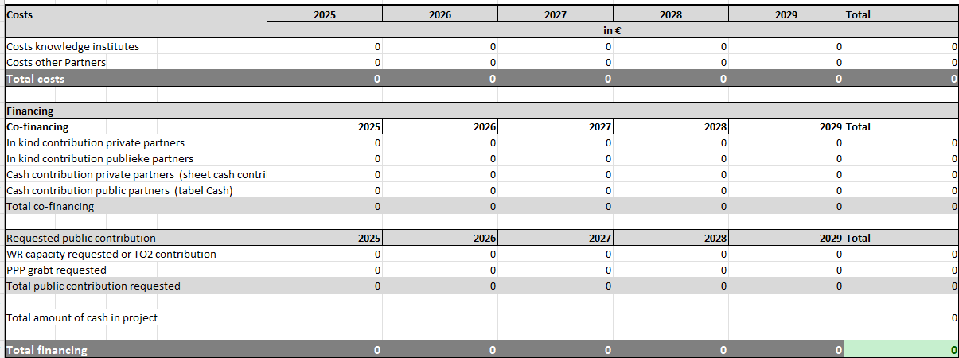

Signature(s) for agreement:
Knowledge institution:
Name:
Signature:
Date:

Private lead:
Name and company/organisation:
Signature:
Date:
Annex 1: Impact Plan
(Max. one and a half page of A4 once completed. Details of the method to be used can be found here (“Impact Plan Approach for KIA LWV”). The Impact Plan Approach should be regarded as a tool to produce a high-quality proposal.
Part A. Problem analysis

1. Societal issue and causes
What is the issue your project is addressing? Who are the relevant stakeholders/actors? What is causing the issue, and which (part) of these causes is down to a lack of knowledge (knowledge gaps)?

Part B. Impact pathway

2. Societal impact (= desired changes in the long term)
In as much detail as possible, please describe which desired long-term societal changes (impact) the project seeks to contribute to.

3.1 Effect (= required actions and activities in the medium term; also known as ‘outcome’)
The ‘effect’ element must describe the steps that are required to achieve societal change. These steps must be described as actions, activities and/or changes in behaviour by public and private parties. Who needs to do what (differently) to achieve societal impact in the long term? If necessary, use the table below as an aid.

Public or private party: | Action, activity and/or change in behaviour: | Project-generated knowledge:
Company X | Company X will produce ... | Improved manufacturing processes ...
Organisation Y | Organisation Y amends the guidelines for ... | Insight into risks relating to ...

3.2 Project results (= knowledge or insights directly generated by the project: project results; also known as ‘output’)
Please describe the desired results of your project (see final column in 3.1). ‘Output’ is the knowledge and insights generated by your project that are needed to realise the outcomes.

3.3 Impact pathway assumptions
Please describe the assumptions that were made when formulating the impact pathway, i.e. the relationship between output, outcome and impact. For example: why will one thing lead to another, or what is needed to achieve change? Please describe how these assumptions will be taken into account in your project.

Annex 2: State of the art and deliverables
Which knowledge, innovations and tools are available in relation to this topic?
What knowledge gaps are there, and how does your project address these?
What will this project deliver in concrete terms?

Annex 3: Comprehensive multi-year work plan
Activities to be carried out
Breakdown of work per partner
Plan of activities and results to be delivered
Decision points

Annex 4: Project fit within priority theme … (max 1 A4)
- Did the lead applicant and project manager participate in the matchmaking session (= required).
- Lead applicant: yes/no
- Project manager: yes/no
- Why does this proposal align with this priority? Please provide a justification.
- Which (sub)questions described in the priority theme are addressed? In what way?
- Specify the intended results and how they contribute to the desired impact (following the SMART principles).

Annex 5: Overview of all participating partners

Partner 1 name
CoC no.
Address and postcode
Town/city
Contact
E-mail address

Partner 2 name
CoC no.
Address and postcode
Town/city
Contact
E-mail address

Partner 3 name
CoC no.
Address and postcode
Town/city
Contact
E-mail address

Projects PPP LWV projects: Projecten; for application purposes: Projectenoverzicht | Projecten Database NL; for fundamental research: Projectendatabank | NWO
If the project is approved, the names of the participating partners will be published in the project database on the KIA LWV website.

